ECA3101-NANO ELECTRONICS
Exp. 3. Simulation of Energy States of Quantum Dot using NanoHub
TEST CASE-1: cylindrical quantum dots
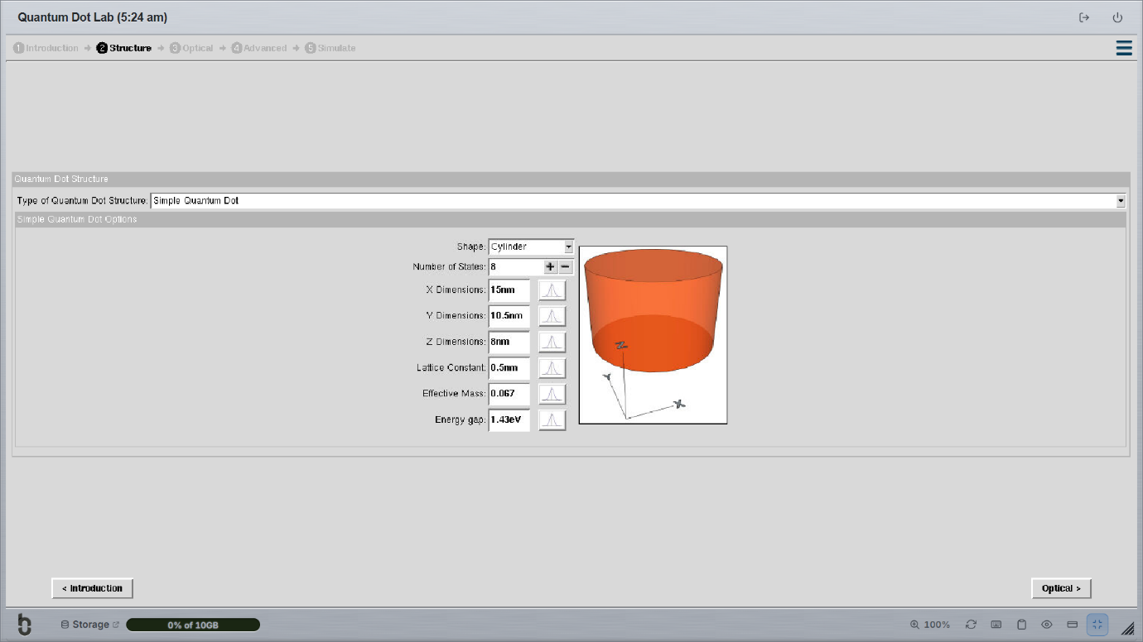
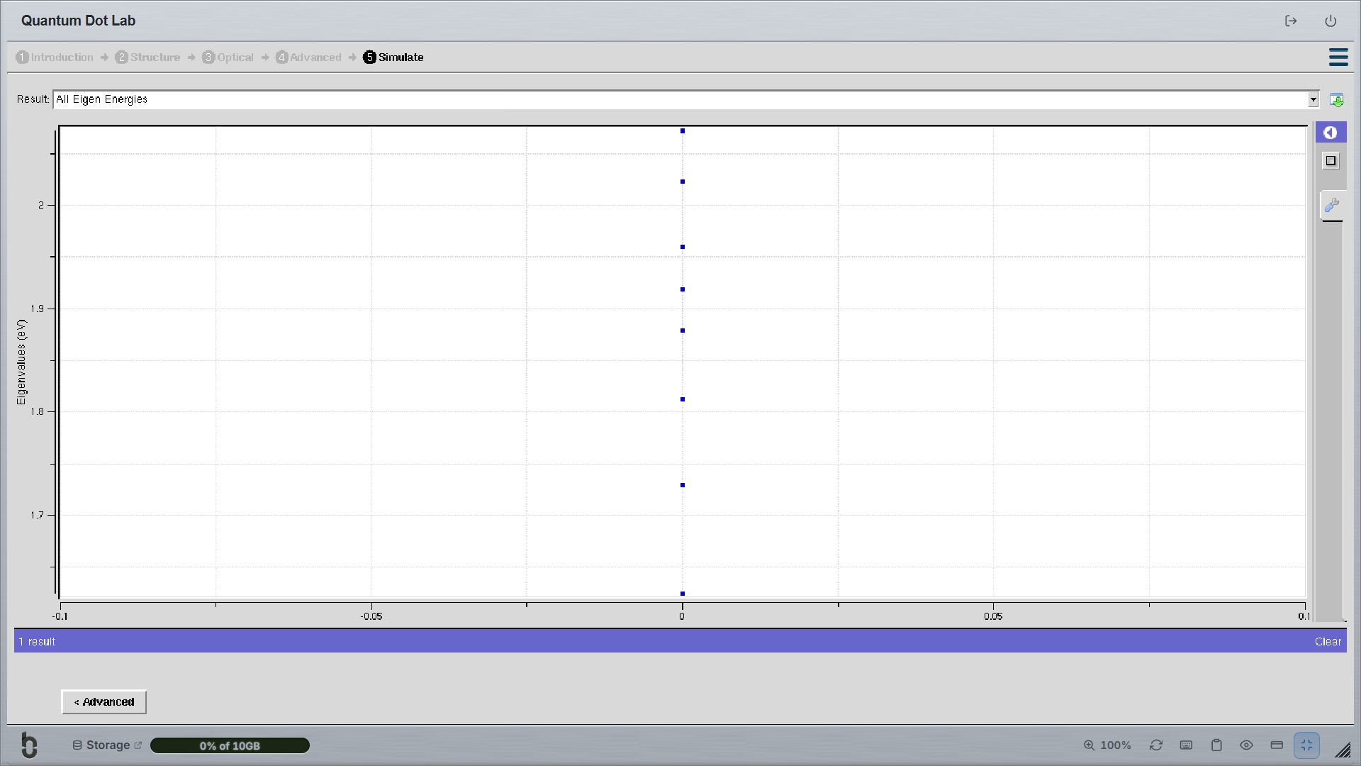

TEST CASE-2:Multi layer cuboid quantum dots


